**Assignment 2 and ASSIGNMENT 3 ques**

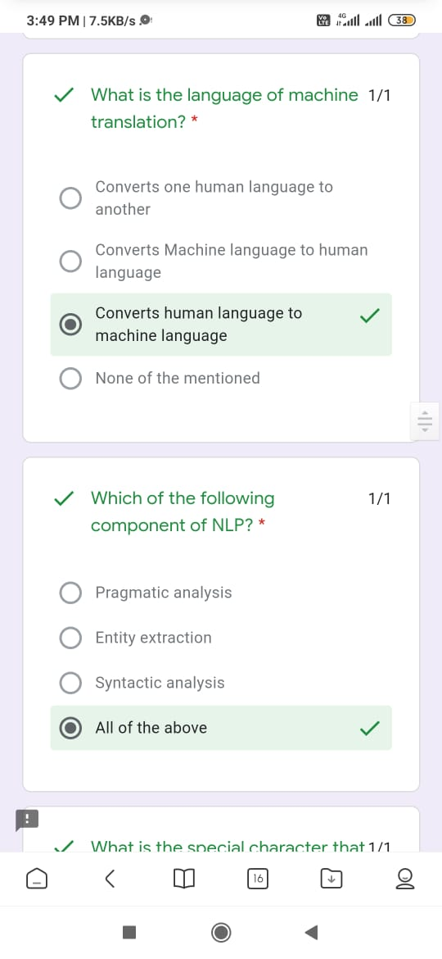 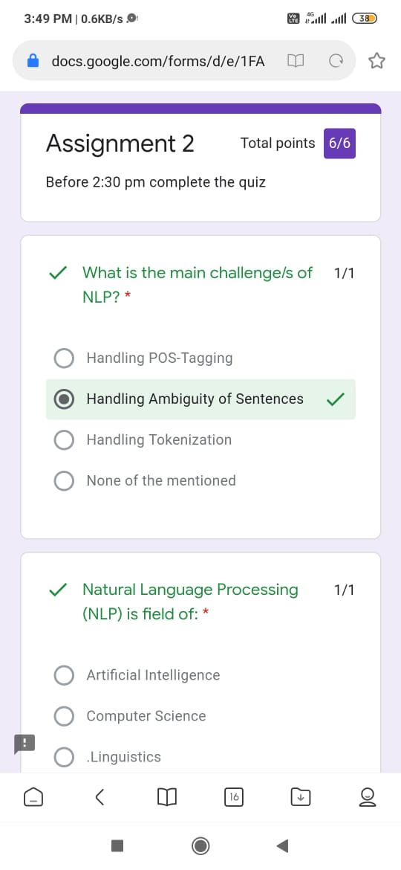

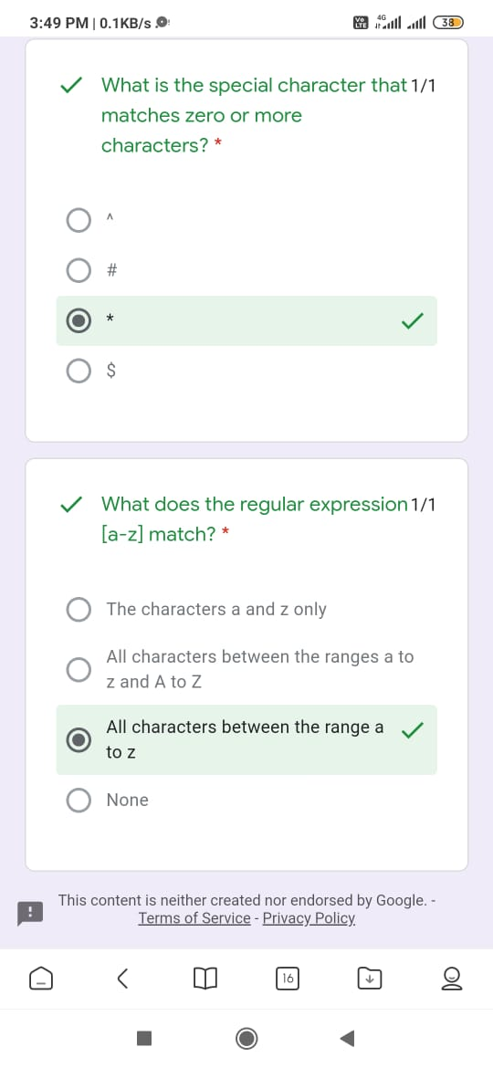

1. What is the output after running the below code:Import nltk, stemmer=nltk.PorterStemmer() , print(stemmer.stem(“raining”),stemmer.stem(“decreases”)) *

* rain,decrease
* raining decrease
* raing decrs
* rain decrease

1. Which is the correct order for preprocessing in Natural Language Processing? *

* tokenization->stemming->lemmatization
* lemmatization->tokenization->stemming
* stemming->tokenization->lemmatization
* None

1. Why do we use named entity recognition in NLP? *

* Classify entities into predefined labels
* Creating a set of vocabularies
* Breaking sentences into words
* None

1. One example of a natural language programming software program used with the iphone is called siri. *

* True
* False

1. What are the step of data pre-processing? *

* Removal of Stopwords
* Removal of Shortwords
* removal of html tags and special characters
* all the above

1. What is the disadvantage of using RNN and the solution? *
2. RNN is used for which type of data ? *

* Video
* Image
* Textual Data
* Signals